**Introduction:**

Selenium is an open-source and a portable automated software testing tool for testing web applications. It has capabilities to operate across different browsers and operating systems. Selenium is not just a single tool but a set of tools that helps testers to automate web-based applications more efficiently.

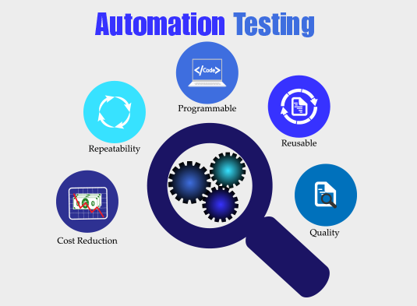

## The Origins of Selenium

[Selenium](https://saucelabs.com/resources/topics/selenium) originated in 2004 by Jason Huggins at [ThoughtWorks](https://www.thoughtworks.com/en-us). Jason was trying to figure out an easy way to [automate testing](https://saucelabs.com/resources/topics/automated-testing) of a time and expense web application.

When asked what name should be given to this tool, Jason gave a flippant, on-the-spot answer: the dominant product at the time was Mercury’s QuickTest Professional, so anyone who hated it and wanted to be “cured” would likely seek out the cure to Mercury poisoning… [which is Selenium](https://pubmed.ncbi.nlm.nih.gov/29124976/)!

## Selenium Tools & Description:

**Selenium IDE**

Selenium **I**ntegrated **D**evelopment **E**nvironment (IDE) is a Firefox plugin that lets testers to record their actions as they follow the workflow that they need to test.

**Selenium RC**

Selenium **R**emote **C**ontrol (RC) was the flagship testing framework that allowed more than simple browser actions and linear execution. It makes use of the full power of programming languages such as Java, C#, PHP, Python, Ruby and PERL to create more complex tests.

**Selenium WebDriver**

Selenium WebDriver is the successor to Selenium RC which sends commands directly to the browser and retrieves results.

**Selenium Grid**

Selenium Grid is a tool used to run parallel tests across different machines and different browsers simultaneously which results in minimized execution time.

**Selenium Web Driver Architecture:**

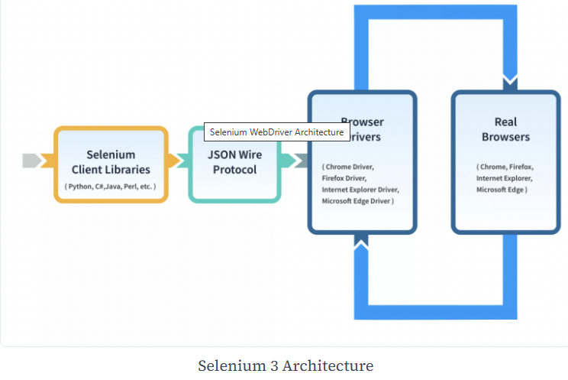

**The Browsers Supported by Selenium**

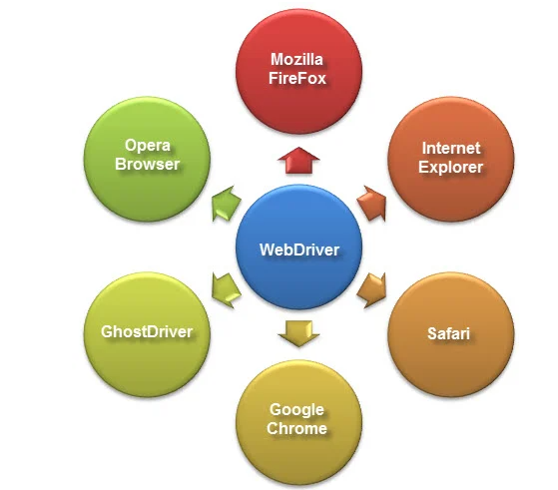

**HTMLUnit is the only browser that WebDriver can directly automate,** meaning that no other separate component is needed to install or run while the test is being executed. For other browsers, a separate program is needed. That program is called the **Driver Server**.

**How to Install Selenium:**

## Selenium WebDriver Installation

Selenium installation is a 3-step process:

**Step 1:** Install Java SDK  
**Step 2:** Install Eclipse  
**Step 3:** Install Selenium Webdriver Files  
**Step 4:** Configure Eclipse IDE with WebDriver

## Difference between Selenium and UFT

Following is the main difference between UFT and Selenium:

| **HP UFT (QTP)** | **Selenium** |
| --- | --- |
| It is commercial tool by Micro Focus and hence it requires a license and is expensive | Its an [open source testing tool](https://www.guru99.com/best-open-source-testing-tools.html)  hence it does not require  license and is free |
| It is used for testing client-server applications. It can test web- based as well as desktop applications | Using Selenium only web  applications can be automated |
| QTP tests can only be developed in  [QTP](https://www.guru99.com/quick-test-professional-qtp-tutorial.html)IDE | Selenium has the option of using  wide range of IDEs like  Visual Studio, Eclipse, Netbeans |
| HP UFT only supports VB script | Selenium supports JAVA,  .NET, Ruby, Perl, PHP and  many other  [programming languages](https://www.guru99.com/best-programming-language.html) |
| HP UFT comes with built in object repository.  Object repository development and  maintenance is quite easy in HP ALM | Selenium dose not have such  built in object repository,  but object can be managed  by using UI element user extension |
| HP UFT integrates with test management  tool like [HP Quality Center](https://www.guru99.com/hp-alm-free-tutorial.html) | There is no such tool that  integrates with Selenium |
| All types of dialog box is supported by UFT Testing | It supports dialog box partially |
| It supports different environments like SAP, Oracle, .NET but user need to purchase add-on license for them | It supports addition of plug-ins to include features that are not provided by core Selenium |
| Automation testing is expensive due to licensing cost | Web automation testing with  Selenium incurs less cost |
| HP QTP offers very good technical support | It has no official support,  since it is an open source |
| HP QTP supports only[VBScript](https://www.guru99.com/vbscript-tutorials-for-beginners.html). Hence  Object Oriented Approach to Test Automation becomes challenging | Selenium supports mature  Object Oriented Language  like Java |
| HP QTP is more user friendly and scripts are  developed quickly. | It is a low level tool with less  functionality. Script requires  more time to develop and maintain |
| Backward compatibility is powerful.  Latest version of HP ALM supports code  that was developed 5 years back | With new Selenium release  the API changes.  So Test Scripts need to be  updated |

**Selenium API:**

<https://www.selenium.dev/selenium/docs/api/java/index.html>

**Important Interfaces**

**WebDriver: (Interface)**

https://www.selenium.dev/selenium/docs/api/java/org/openqa/selenium/WebDriver.html

**WebElement: (Interface)**

<https://www.selenium.dev/selenium/docs/api/java/org/openqa/selenium/WebElement.html>

**TakesScreenshot :Interface**

<https://www.selenium.dev/selenium/docs/api/java/org/openqa/selenium/TakesScreenshot.html>

# JavascriptExecutor

https://www.selenium.dev/selenium/docs/api/java/org/openqa/selenium/JavascriptExecutor.html

**Important Classes:**

**By: (Class)**

<https://www.selenium.dev/selenium/docs/api/java/org/openqa/selenium/By.html>

**Cookie: (Class)**

<https://www.selenium.dev/selenium/docs/api/java/org/openqa/selenium/Cookie.html>

**Dimension:(Class)**

https://www.selenium.dev/selenium/docs/api/java/org/openqa/selenium/Dimension.html

**Keys: (Enum Class)**

https://www.selenium.dev/selenium/docs/api/java/org/openqa/selenium/Keys.html

**Point:**

<https://www.selenium.dev/selenium/docs/api/java/org/openqa/selenium/Point.html>

**Events:**

<https://www.selenium.dev/selenium/docs/api/java/org/openqa/selenium/events/package-summary.html>

|  |  |
| --- | --- |
|  |  |
|  |  |
|  |  |
|  |  |
|  |  |